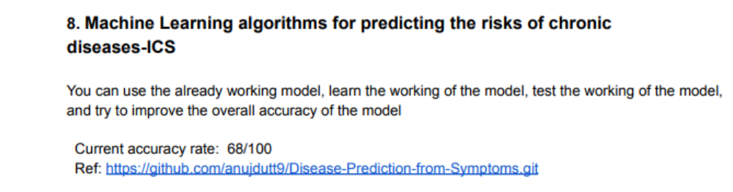

After tuning model

